ICP9

ICP Group 4

Source code: <https://github.com/UMKC-APL-WebMobileProgramming/ICP9-SailajaNarra>

Video: <https://umsystem.hosted.panopto.com/Panopto/Pages/Viewer.aspx?id=65c9ea3d-2f41-438d-ab01-add30038763b>

In this task we have learnt about the creation of different layouts and its usages. Sending email is an primary option in this task.

Also learnt about creating an app launcher icon in the Image asset Studio.

For this task there is already source code given and we have done the enhancements and necessary page layouts and summary page creation.

1. Initially page layout is created with proper headings and user input details

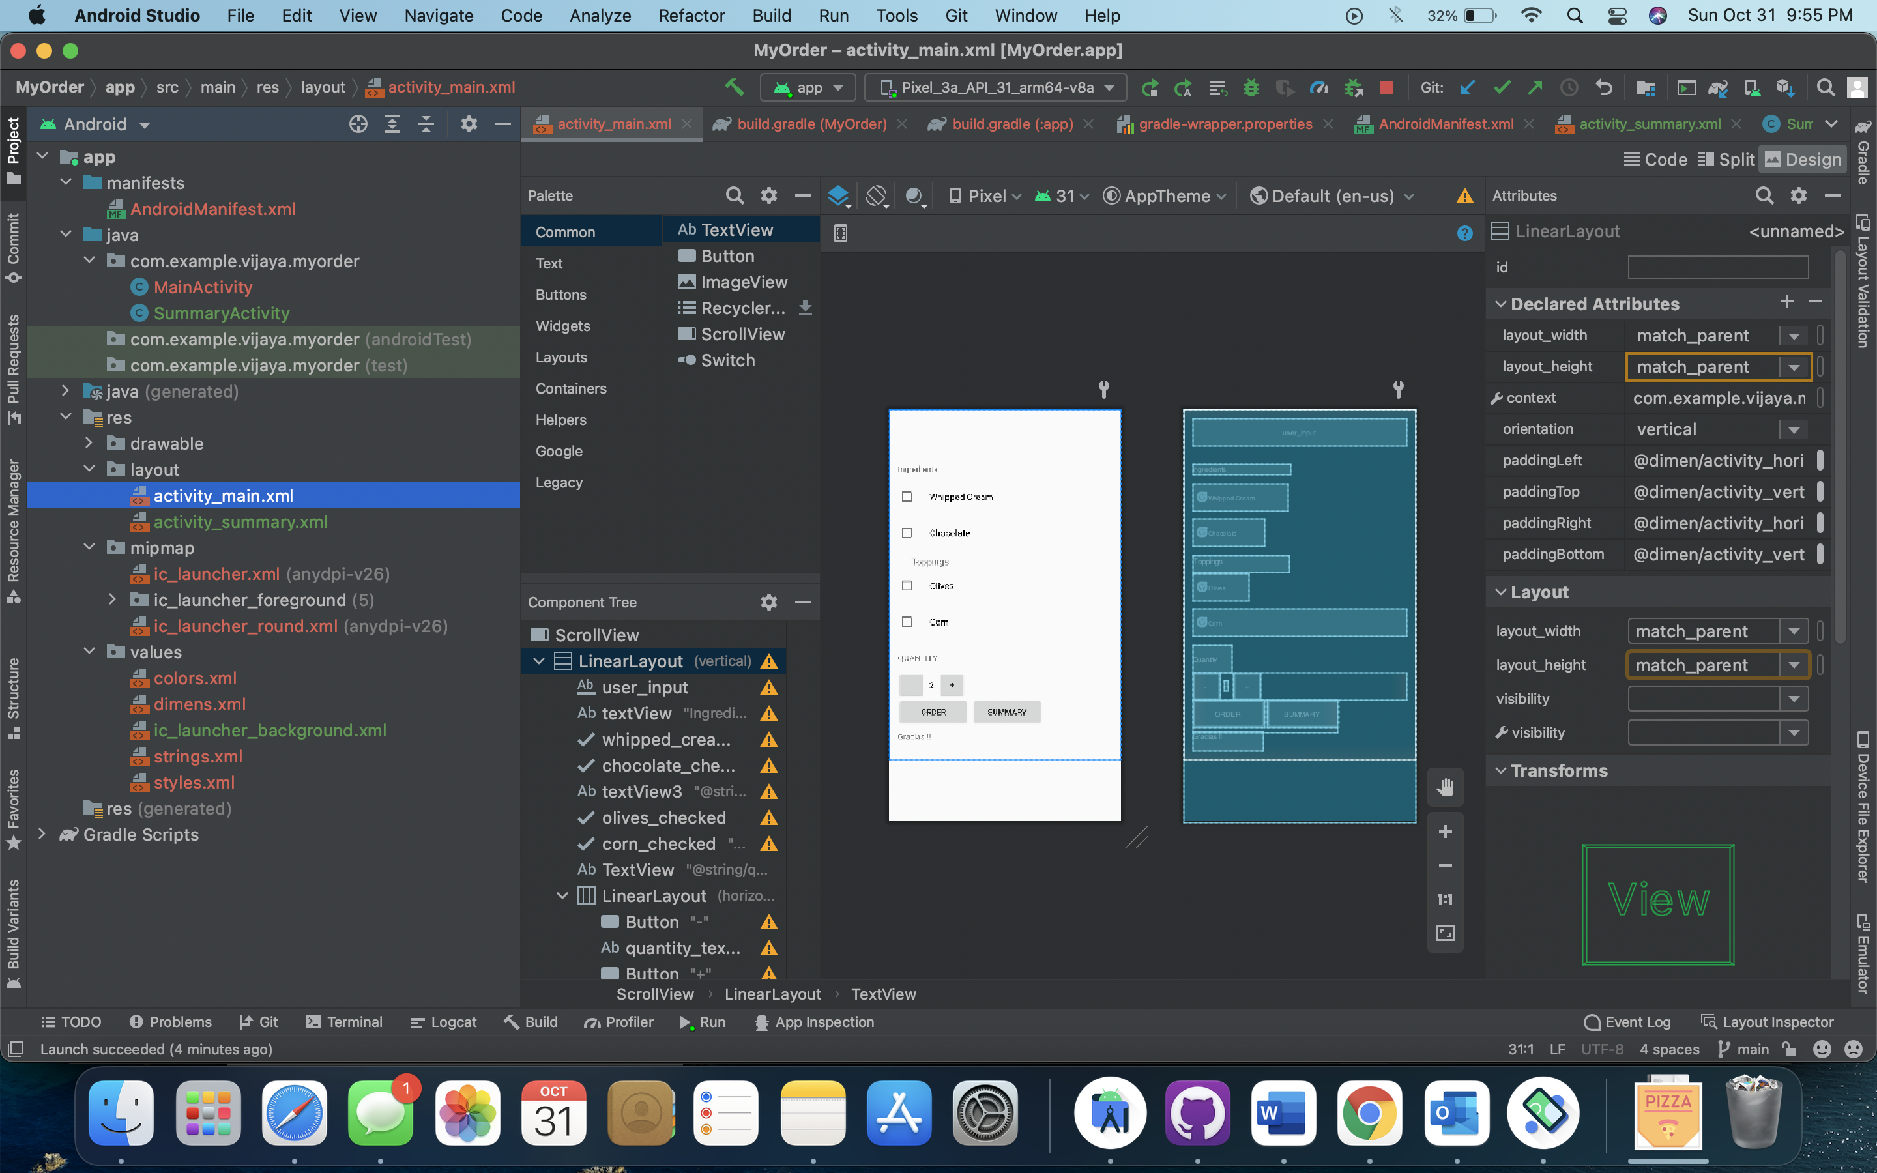

User name is added as a text field and some of the toppings checkbox buttons are created and re aligned the quantity buttons.

Taken a vertical layout and created two buttons order and summary.

Below is the design screen for reference.

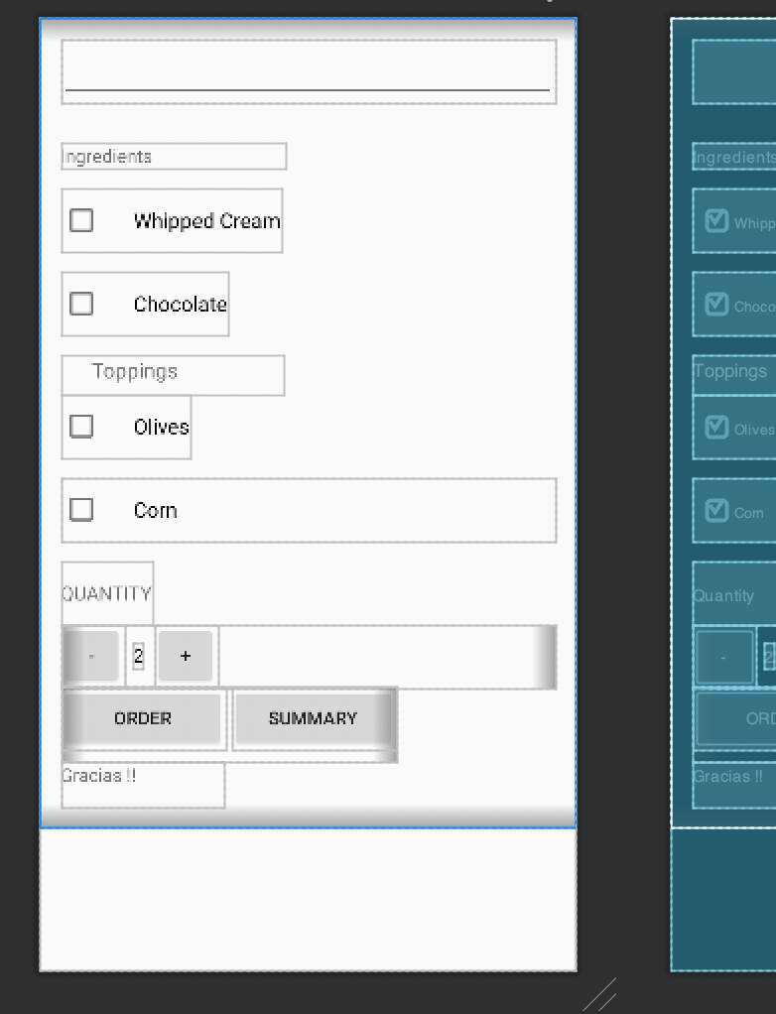

1. In the “MainActivity.java” file these buttons references are taken and added the business logic

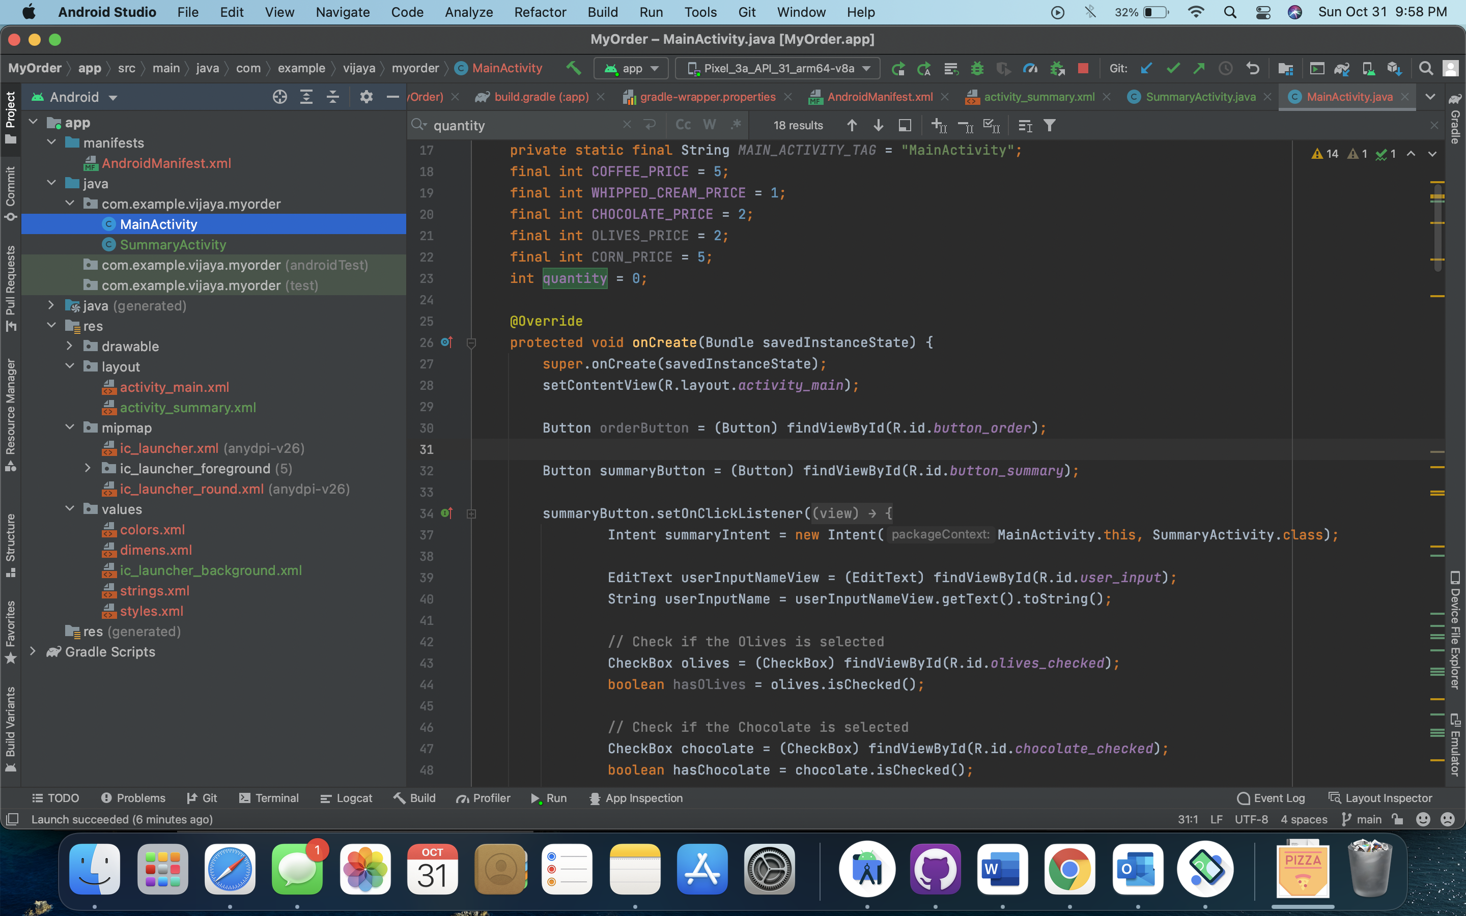

On click of summary button

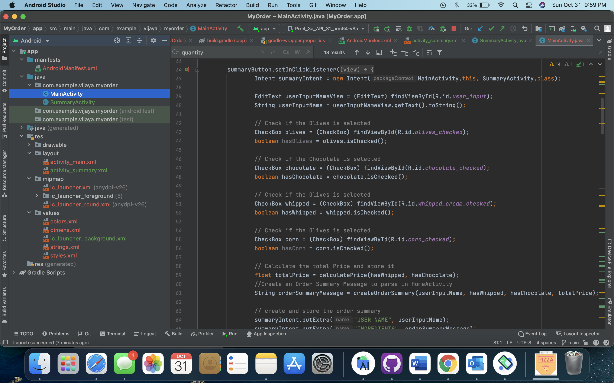

Design page for Summary details

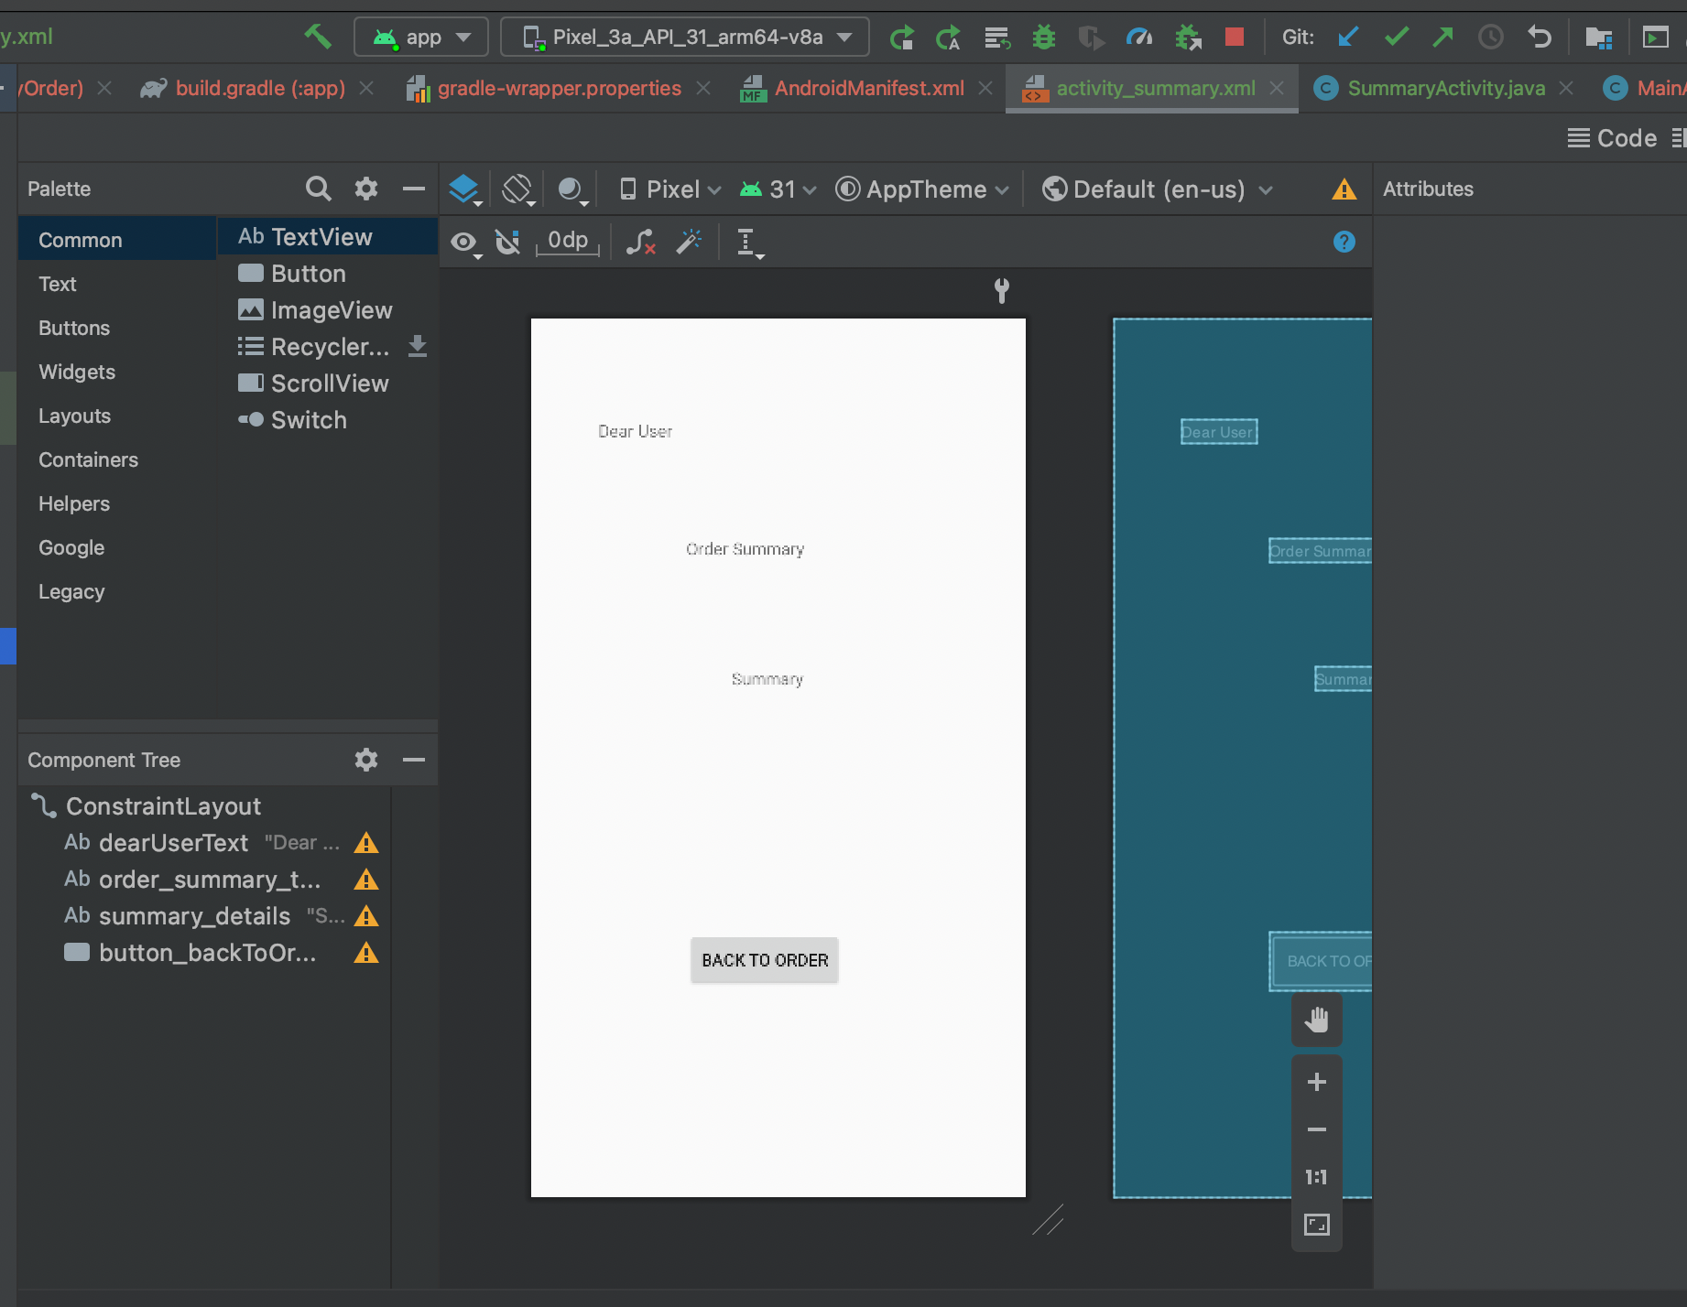

On click of order button submit order method will be called.

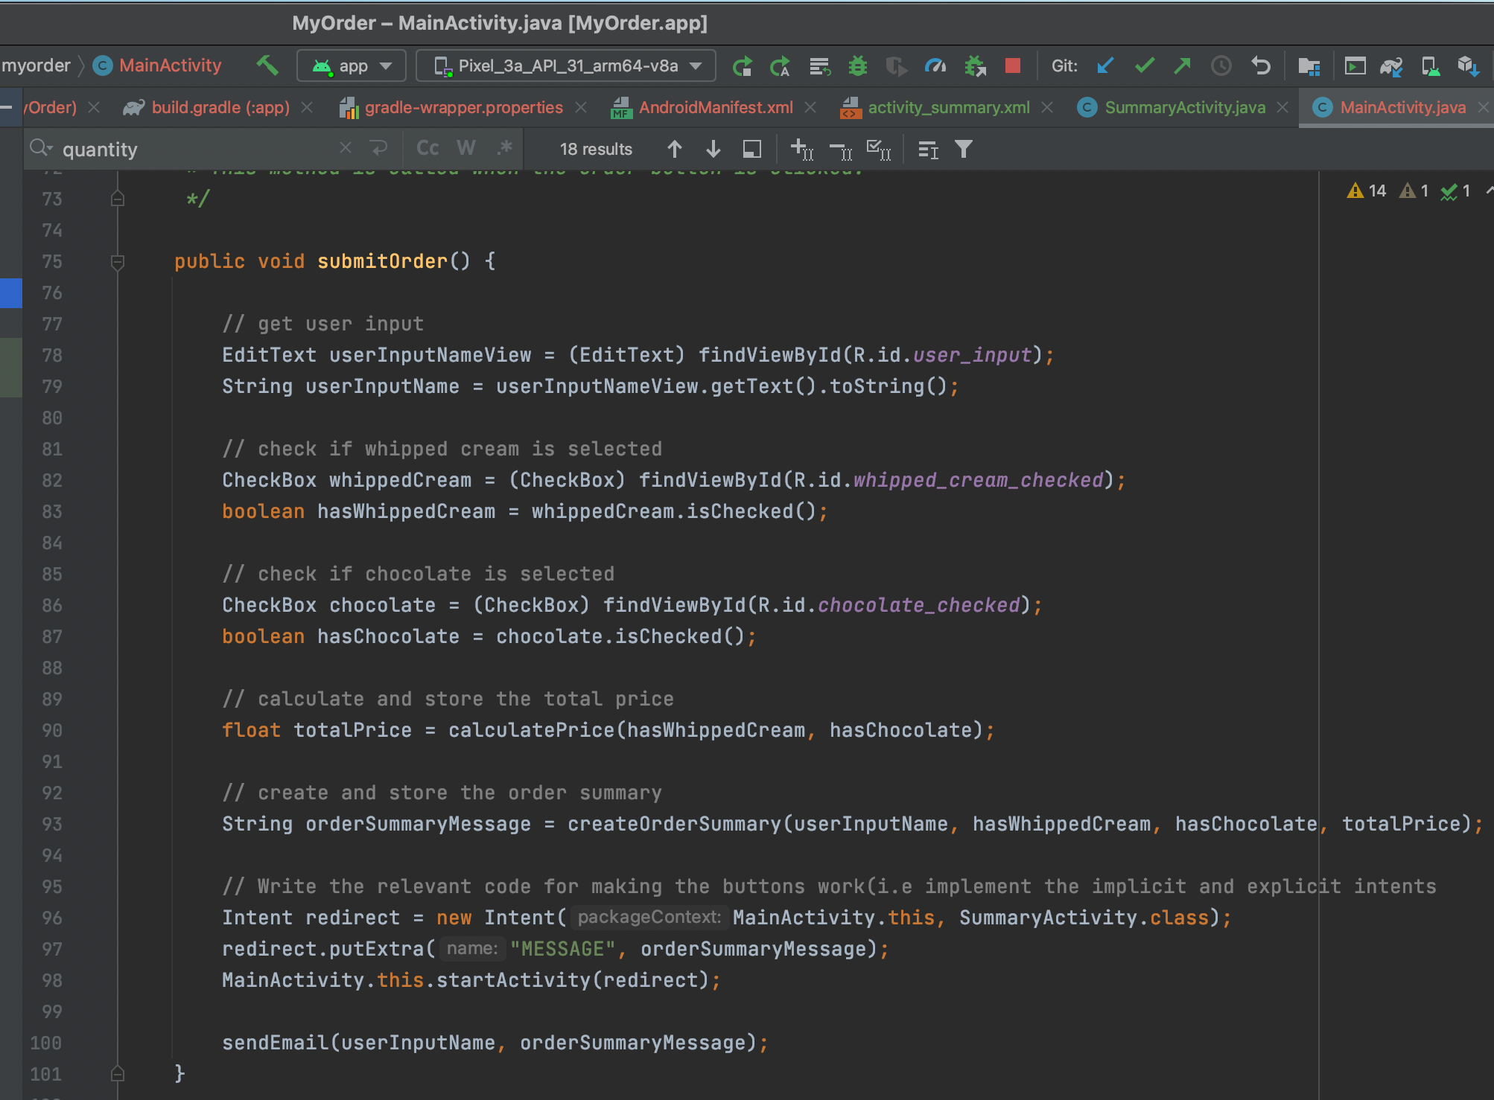

Mapping the method to the button in design

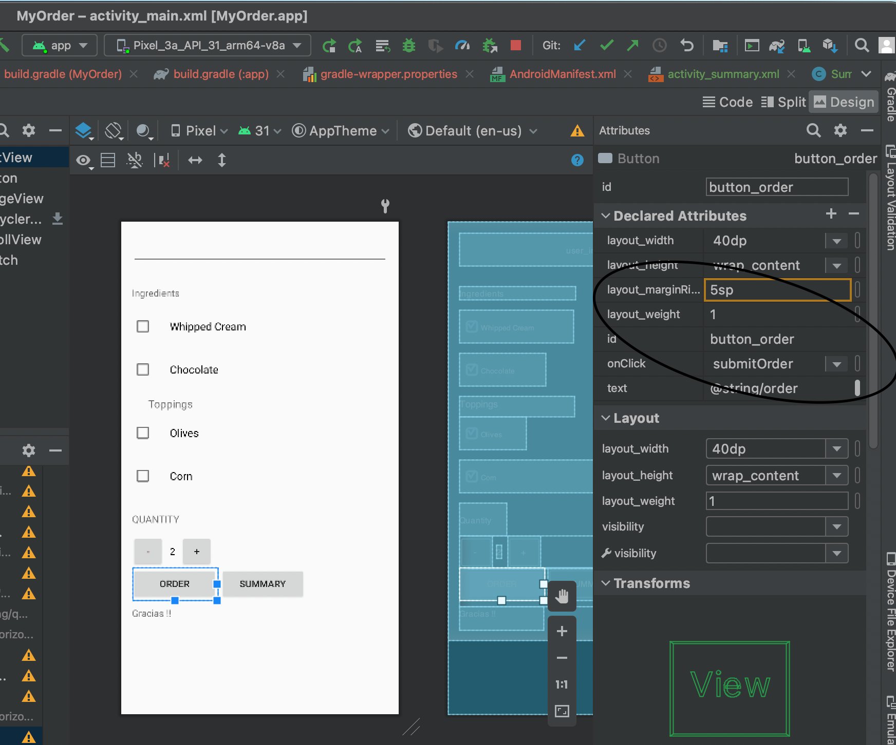

Summary activity file

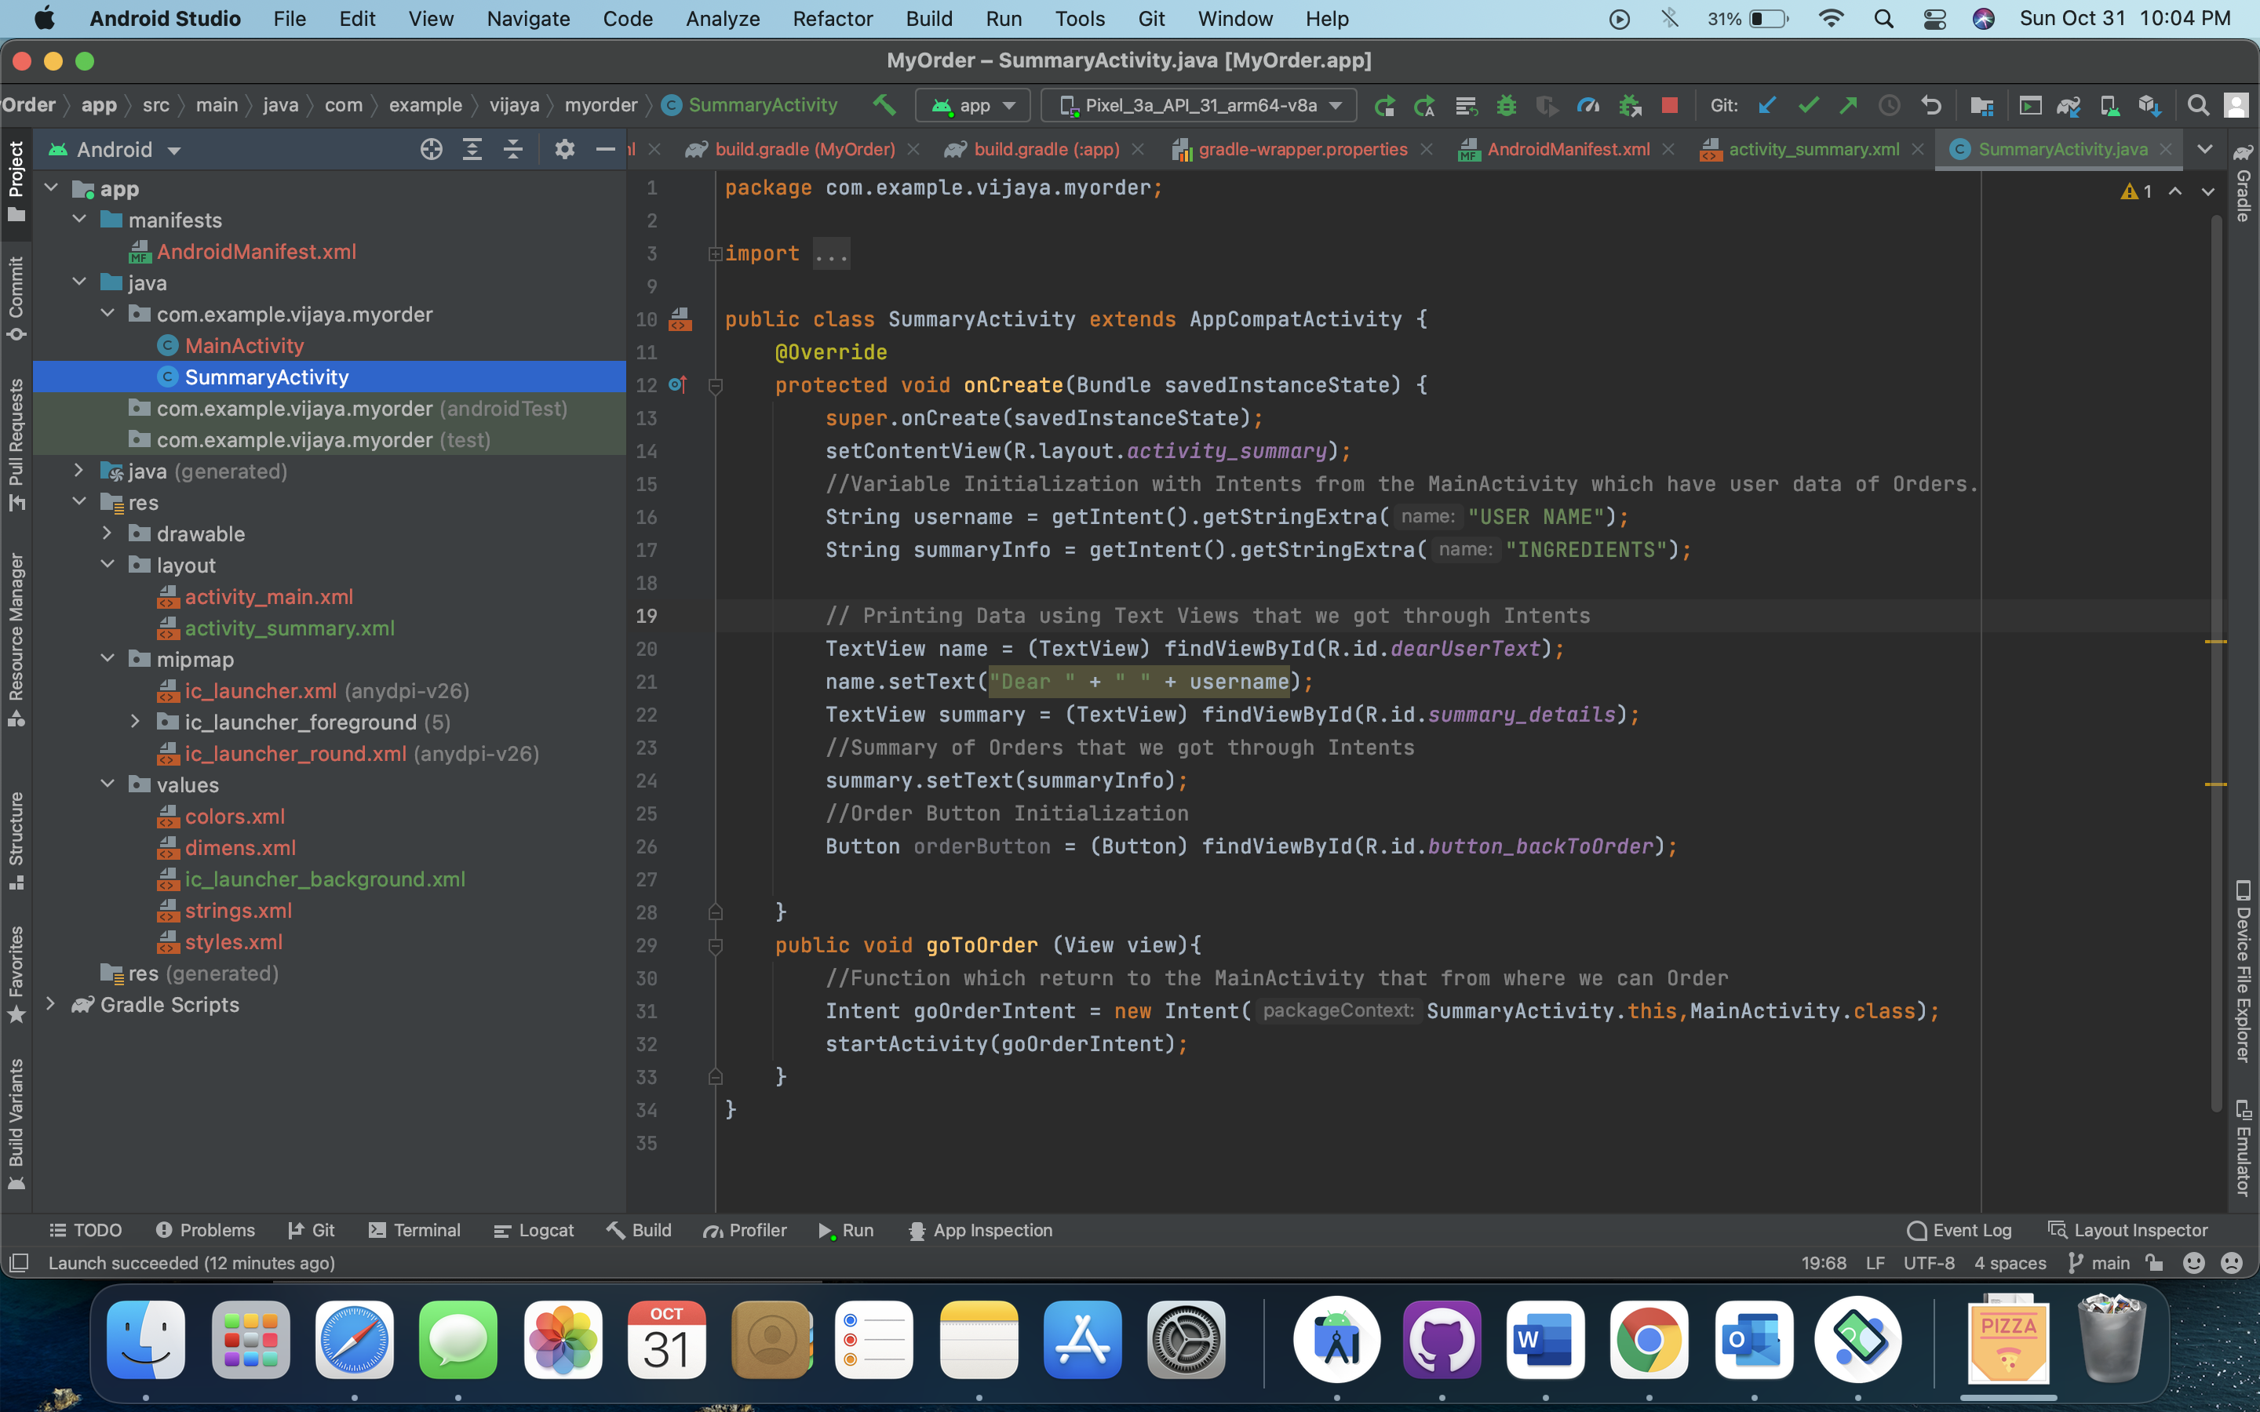

Send email method

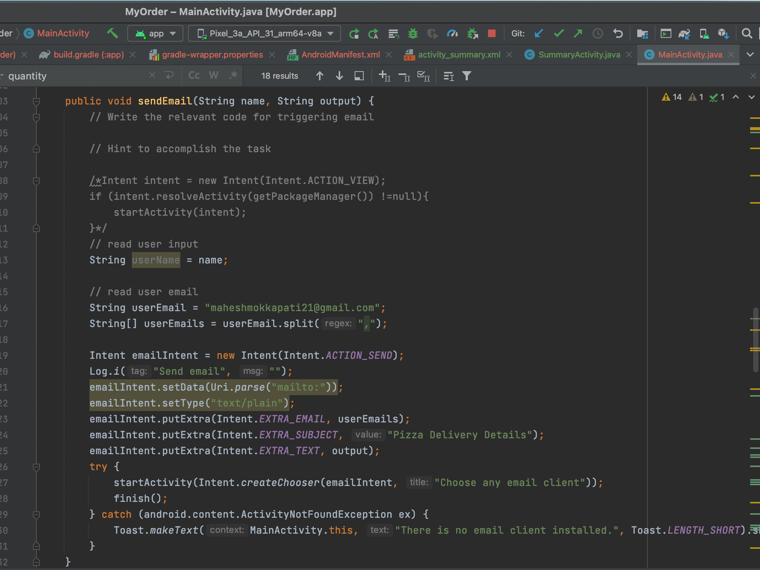

A new app launcher icon is created using Image asset studio

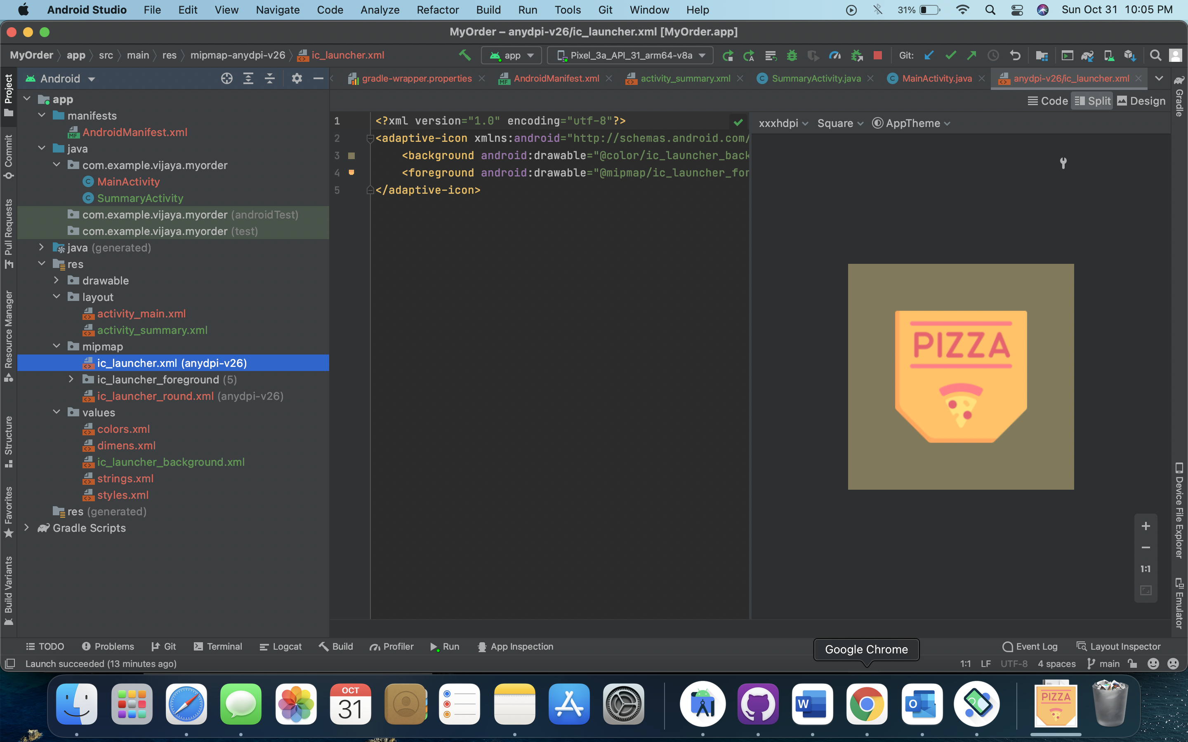

Downloaded the icon from the flat icons

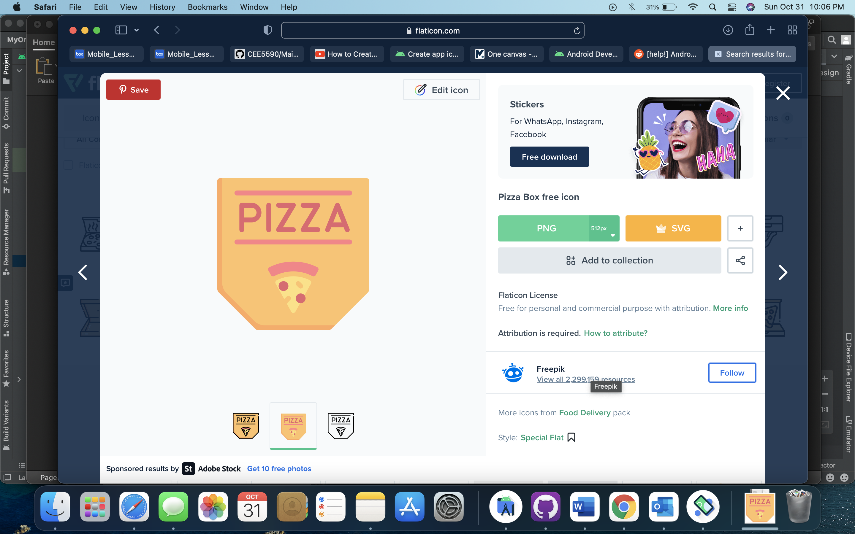

Output

